Request Confirmation Messages
Write a query to find the IDs of the users that requested a confirmation message twice within a 24-hour window.
Note:
- Two messages exactly 24 hours apart are considered to be within the window.
- The action does not affect the answer, only the request time.
- Return the result table ordered by user_id in an ascending manner.
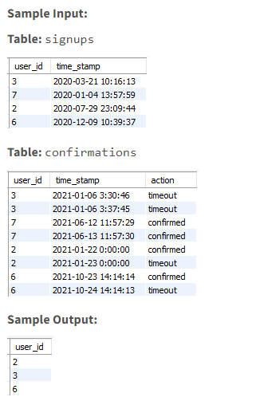
SELECT DISTINCT user_id
FROM(SELECT user_id,time_stamp,
LAG(time_stamp) OVER (PARTITION BY user_id ORDER BY time_stamp ASC) AS prev_time_stamp,
TIMESTAMPDIFF(SECOND, LAG(time_stamp) OVER (PARTITION BY user_id ORDER BY time_stamp ASC), time_stamp) AS time_diff_seconds
FROM confirmations
)A
WHERE time_diff_seconds <= 86400
ORDER BY user_id;
Six months
Problem Statement:
Write a query to display the details of those employees who were hired between the given date '1998-01-01' and six months before from the given date and also whose salary is highest in each department.
- Return the columns 'employee_id', 'first_name', 'last_name', 'salary', 'hire_date', 'department_id'.
- Return the result ordered by department_id and employee_id in ascending order.
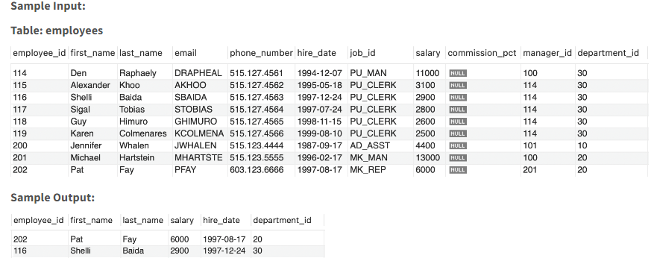
select employee_id,first_name,last_name,salary,hire_date,department_id
from(select employee_id,first_name,last_name,salary,hire_date,department_id,
dense_rank() over(partition by department_id order by salary desc) as salary_rank
from employees
where hire_date between date_sub("1998-01-01", interval 6 month) and "1998-01-01")t
where salary_rank=1
order by department_id,employee_id

Sales Quartile
Problem Description:
Write a query to get the total amount for each customer who made payments along with their sales quartile based on the amount in descending order.
- Quartile refers to any of the 4 equal bins into which a data set can be divided, based on the values of a particular variable.
  - Here, based on the total_amount we need to divide data into 4 equal bins. Where the 1st bin consists of the highest total_amount and the 4th bin consists of the lowest total_amount.
- Order the output by total_amount in descending order and by sales_quartile in ascending order.
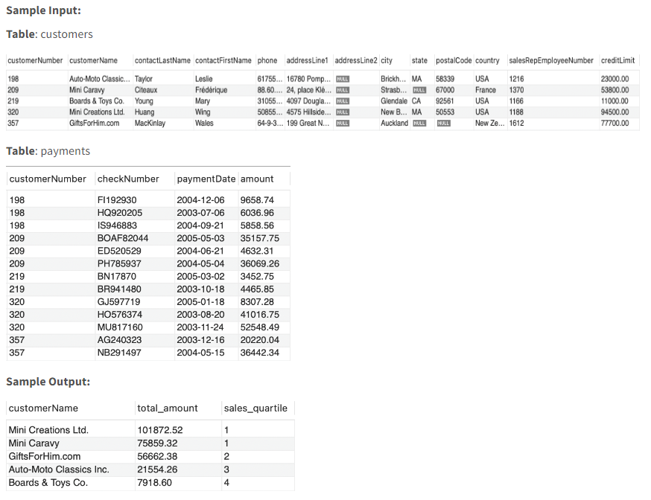
select customerName,total_amount,ntile(4)
over(order by total_amount desc) as sales_quartile from
(select distinct c.customerNumber as customerNumber,
c.customerName as customerName,sum(p.amount) over(partition by c.customerNumber) as total_amount
from payments p inner join customers c
on p.customerNumber=c.customerNumber)t
order by total_amount desc,sales_quartile

Third Highest Sales
Write a query to compare each sale of a customer with 3rd highest sale of that customer.
- Order the output by customerNumber in ascending order and by sales in descending order.
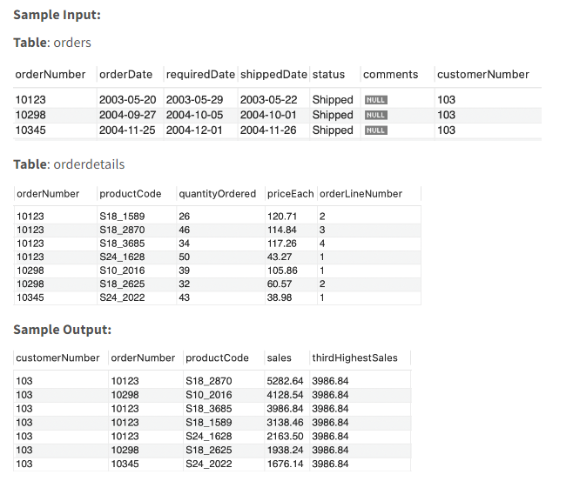
SELECT o.customerNumber,o.orderNumber,od.productCode,(od.quantityOrdered * od.priceEach) AS sales,
NTH_VALUE(od.quantityOrdered * od.priceEach, 3)
OVER (PARTITION BY o.customerNumber ORDER BY od.quantityOrdered * od.priceEach DESC
RANGE BETWEEN UNBOUNDED PRECEDING AND UNBOUNDED FOLLOWING) AS thirdHighestSales
FROM orders o INNER JOIN orderdetails od
ON o.orderNumber = od.orderNumber
ORDER BY o.customerNumber ASC,sales DESC;

28 years
Problem Statement:
Write a query to display the employee's details and calculate the total no.of years the employees have been working in the company till 8th June 2022 and save it as 'Total_years'.
Return the details of those employees who have been working for atleast 28 years.
- Return the columns 'employee_id', 'first_name', 'last_name', and 'Total_years'.
- Return the result ordered by employee_id in ascending order.
Note:
- To get the "Total_years" calculate the date difference and divide the difference by 365.
- Round the total calculated years up to two decimal points.
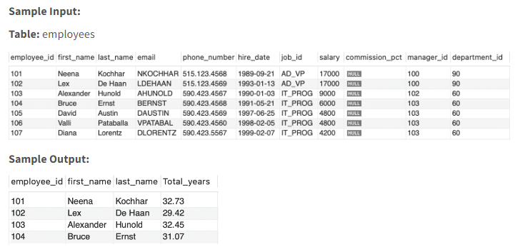
select * from(select employee_id,first_name,last_name,round(datediff('2022-06-08',hire_date)/365,2) as Total_years
from employees)t
where Total_years >=28
order by employee_id

Day, Month, Year
Problem Statement:
Write a query to extract the day, month, and year from the hire_date of the employees and save the columns as 'Day', 'Month', and 'Year'.
Display the extracted columns and the details of those employees who were hired in the year 2000 and in January month and also salary is greater than 5000.
- Return the columns 'employee_id', 'first_name', 'last_name', 'salary', 'hire_date', 'Day', 'Month', 'Year'.
- Return the results ordered by employee_id in ascending order.
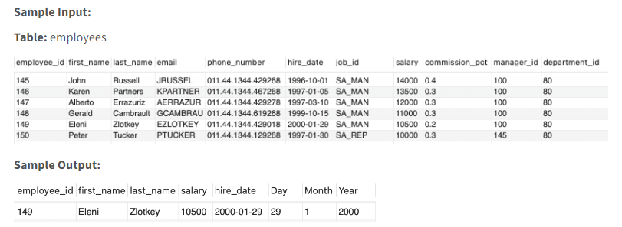
select employee_id,first_name,last_name,salary,hire_date,
day(hire_date) as "Day",
month(hire_date) as "Month",
year(hire_date) as "Year"
from employees
where year(hire_date) = 2000
and month(hire_date) = 1
and salary > 5000
order by employee_id

Salary Decile
Problem Description:
Write a query to list all departments and their average salary, along with their decile based on the average salary in descending order.
- Decile refers to any of the 10 equal bins into which a data set can be divided, based on the values of a particular variable.
  - Here, based on the average salary we need to divide data into 10 equal bins. Where 1st bin consists highest average salaries and the 10th bin consists of the lowest average salaries.
- Order the output by avg_salary in descending order and by salary_decile in ascending order.
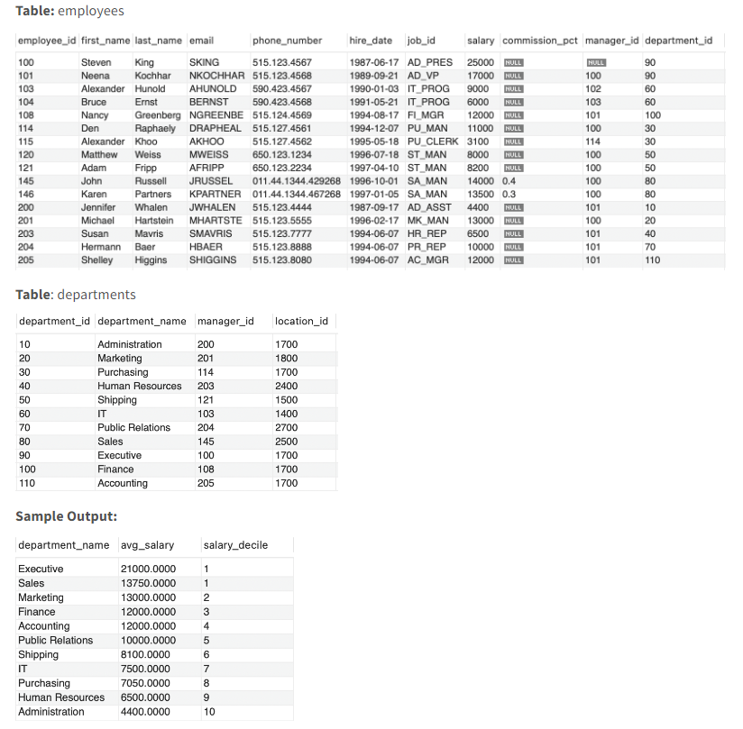
select *,ntile(10) over(order by avg_salary desc) as salary_decile
from(select distinct d.department_name,avg(e.salary)
over(partition by d.department_id) as avg_salary
from employees e
join departments d
on e.department_id=d.department_id)t
order by avg_salary desc,salary_decile

Q6. Salaries after taxes
Problem Description:
Write a query to find the salaries of the employees after applying taxes. Round the salary to the nearest integer.
The tax rate is calculated for each company based on the following criteria:
- 0% If the max salary of any employee in the company is less than $1000.
- 24% If the max salary of any employee in the company is in the range [1000, 10000] inclusive.
- 49% If the max salary of any employee in the company is greater than $10000.
- The salary after taxes = salary - salary x (taxes percentage / 100).
- Return the result ordered by company_id, and employee_id in ascending order.
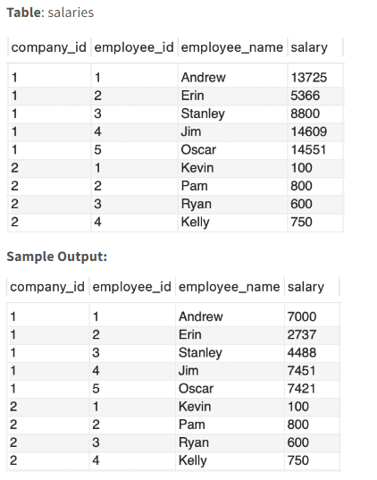
SELECT company_id,employee_id, employee_name,
ROUND(salary - salary *
(CASE
WHEN max_salary < 1000 THEN 0
WHEN max_salary BETWEEN 1000 AND 10000 THEN 24
ELSE 49
END) / 100) AS salary FROM(SELECT company_id,employee_id,employee_name,salary,MAX(salary) OVER (PARTITION BY company_id) AS max_salary FROM salaries) AS salary_data
ORDER BY company_id, employee_id;

Matches of the League
Problem Statement:
Write a query that reports all the possible matches of the league.
- Note that every two teams play two matches with each other, with one team being the home_team once and the other time being the away_team.
- Return the result table ordered by home_team and away_team in an ascending manner.
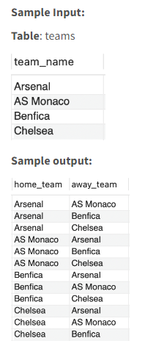
SELECT t1.team_name as home_team,t2.team_name as away_team
from teams t1,teams t2
where t1.team_name <> t2.team_name
order by t1.team_name,t2.team_name
Order Two Columns Independently
Problem Statement:
Write a query to independently:
- order first_col in ascending order.
- order second_col in descending order.
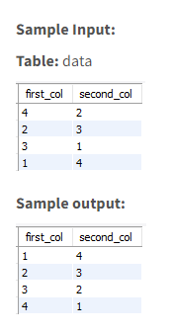
select first_col,second_col
from
(select first_col, row_number() over(order by first_col) as r from data) a join
(select second_col, row_number() over(order by second_col desc) as r from data) b
on a.r=b.r

